**Krishtechtrainings**

[**https://krishtechtrainings.com**](https://krishtechtrainings.com) **| +918595014719**

**Amazon Web Services Interview Questions - Basic**

**1. What are Amazon Web Services?**

AWS stands for [Amazon Web Services](https://mindmajix.com/what-is-aws), which is a cloud computing platform. It is designed in such a way that it provides cloud services in the form of small building blocks, and these blocks help create and deploy various types of applications in the cloud. These sequences of small blocks are integrated to deliver the services in a highly scalable manner.

|  |
| --- |
|  |

**2. What are the Main Components of AWS?**

The Key Components of AWS are:

* **Simple Email Service:** It allows you to send emails with the help of regular SMTP or by using a restful API call
* **Route 53:** It’s a DNS web service.
* **Simple Storage Device S3:** It is a widely used storage device service in AWS Identity and Access Management
* **Elastic compute cloud( EC2):** It acts as an on-demand computing resource for hosting applications. EC2 is very helpful in times of uncertain workloads.
* **Elastic Block Store:** It allows you to store constant volumes of data which is integrated with EC2 and enables you to data persist.
* **Cloud watch:** It allows you to watch the critical areas of the AWS with which you can even set a reminder for troubleshooting.

|  |
| --- |
|  |

**3. Explain what S3 is all about?**

S3 is the abbreviation for a simple storage service. It is used for storing and retrieving data at any time and anywhere on the web. S3 makes web-scale computing easier for developers. The payment mode of S3 is available on a pay-as-you-go basis.

**4. What is AMI?**

It stands for Amazon Machine Image. The AMI contains essential information required to launch an instance, and it is a copy of AMI running in the cloud. You can download as many examples as possible from multiple AIMs.

|  |
| --- |
|  |

**5. What is the relationship between an instance and AMI?**

Using a single AMI, you can download as many instances as you can. An instance type is used to define the hardware of the host computer for your situation. Each instance is unique and provides the facilities in computational and storage capabilities. Once you install an instance, it looks similar to a traditional host with which we can interact in the same way we do with a computer.

**6. What are the things that are included in the AIM?**

An AIM consists of the things which are mentioned below:

* A template for the instance
* Launch permissions
* A block mapping that decides the volume to be attached when it gets launched.

|  |
| --- |
|  |

**7. What is an EIP?**

The Elastic IP address (EIP) is a static Ipv4 address offered by AWS to manage dynamic cloud computing services. Connect your AWS account with EIP so that if you want a static IPv4 address for your instance, you can be associated with the EIP which enables communication with the internet.

**8. What is CloudFront?**

CloudFront is a content delivery network offered by AWS, and it speeds up the distribution of dynamic and static web content such as .css, .js, .html, and image files to the users. It delivers the content with low latency and high transfer speed to the users. AWS provides CDN for less price and it suits the best startups.

**9. What is VPC?**

Virtual Private Cloud (VPC) allows you to launch AWS resources into the virtual network. It allows users to create and customize network configurations according to users’ business requirements.

**10. What is the VPC peering connection?**

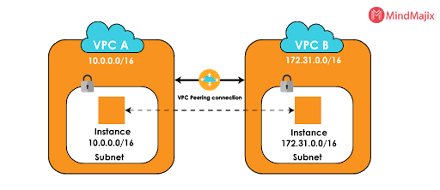

VPC peering connection is a networking connection that allows connecting one VPC with the other. It enables the route traffic between two VPCs using IPv6 and Ipv4 addresses. Instances within the VPCs behave like as they are in the same network.

**11. What is the procedure to send a request to Amazon S3?**

S3 in Amazon is a REST service, and you can send requests by using the AWS SDK or REST API wrapper libraries.

**12. What are NAT gateways?**

[Network Address Translation](https://en.wikipedia.org/wiki/Network_address_translation)(NAT) allows instances to connect in a private subnet with the internet and other AWS services. NAT prevents the internet to have an initial connection with the instances.

**13. What is SNS?**

[Amazon Simple Notification Service](https://en.wikipedia.org/wiki/Amazon_Simple_Notification_Service) (SNS )is a web service provided by AWS. It manages and delivers messages or notifications to users and clients from any cloud platform. In SNS, there are two types of clients: subscribers and publishers. Publishers produce and send a message to the subscriber instance through the communication channels. Subscribers receive notification from the publisher over one of the supported protocols such as Amazon SQS, HTTP, and Lambda, etc. Amazon SNS automatically triggers the service and sends an email with a message that “ your EC2 instance is growing” when you are using Auto Scaling.

**14. What is SQS?**

Amazon SQS stands for Simple Queue Service, and it manages the message queue service. Using this service, you can move the data or message from one application to another even though it is not in the running or active state. SQS sends messages between multiple services, including S3, DynamoDB, EC2 Instance, and also it uses the Java message queue service to deliver the information. The maximum visibility timeout of a message is 12 hours in the SQS queue.

|  |
| --- |
|  |

**15. What are the types of queues in SQS?**

There are two types of queues in SQS. They are as follows:

**Standard Queues:** It is a default queue type. It provides an unlimited number of transactions per second and at least one message delivery option.

**FIFO Queues:** FIFO queues are designed to ensure that the order of messages is received and sent is strictly preserved as in the exact order that they sent.

**16. Explain the types of instances available?**

Below stated are the available instances:

* General-purpose
* Storage optimized
* Accelerated computing
* Computer-optimized
* Memory-optimized

**17. Explain about DynamoDB?**

If you want to have a faster and flexible NoSQL database, then the right thing available is [DynamoDB](https://en.wikipedia.org/wiki/Amazon_DynamoDB), which is a flexible and efficient database model available in Amazon web services.

**18. What is Glacier?**

Amazon Glacier is one of the most important services provided by AWS. The Glacier is an online web storage service that provides you with low-cost and effective storage with security features for archival and data backup. With Glacier, you can store the information effectively for months, years, or even decades.

**19. What is Redshift?**

Redshift is a big data product used as a data warehouse in the cloud. It is the fast, reliable, and powerful product of a big data warehouse.

|  |
| --- |
|  |

**20. What are the Types of AMI Provided by AWS?**

Below listed are the two kinds of AMIs provided by AWS:

* EBS backed
* Instance store backed

*Till now, you have seen basic interview questions. Now, we will move to the Intermediate Questions.*

**Amazon Web Services Interview Questions - Intermediate Level**

**21. What is an ELB?**

Elastic Load Balancer( [ELB](https://mindmajix.com/what-is-aws-elb)) is a load balancing service offered by AWS. It distributes incoming resources and controls the application traffic to meet traffic demands.

**22. What are the types of load balancers in EC2?**

There are three types of load balancers in EC2. They are as follows:

**Application Load Balancer:** The application load balancer is designed to make routing decisions at the application layer. ALC supports dynamic host port mapping and path-based routings.

**Network Load Balancer:** [Network load balancer](https://en.wikipedia.org/wiki/Network_Load_Balancing) is designed to make routing decisions at the transport layer. It handles millions of requests per second. Using the flow hash routing algorithm, NCL selects the target from the target groups after receiving a connection from the load balancer.

**Classic Load Balancer:** Classic load balancer is designed to make routing decisions either at the application layer or transport layer. It requires a fixed relationship between the container instance port and the load balancer port.

**23. Explain what is a T2 instance?**



The T2 instance is one of the low-cost Amazon instances that provides a baseline level of CPU performance.

**24. Mention the security best practices for Amazon EC2.**

Security best practices for Amazon EC2 are as below:

* Security and network
* Storage
* Resource Management
* Recovery and Backup

**25. While connecting to your instance, what are the possible connection issues one might face?**

The following are the connection issues faced by the user:

* User key not recognized by the server
* Permission denied
* Connection timeout
* Cannot connect using user’s browser
* Server unexpectedly closed network connection
* Unprotected private key
* Cannot ping the instance
* Server refused host key
* The private key must begin with **“*BEGIN RSA PRIVATE KEY*”** and end with **“ *END RSA PRIVATE KEY*.”**

**26. What are key pairs in AWS?**

Amazon EC2 uses both public and private keys to encrypt and decrypt the login information. The sender uses a public key to encrypt the data and the receiver uses a private key to decrypt the data. Private and public keys are known as key pairs. The public key enables you to access the instance securely and a private key is used instead of a password.

**27. What is SimpleDB?**

[SimpleDB](https://en.wikipedia.org/wiki/Amazon_SimpleDB)is one of Amazon's services offered by AWS. It is a distributed database and highly available NoSQL data store that offloads the work of database administrators.

**28. What is Elastic Beanstalk?**

Elastic Beanstalk is the best service offered by AWS for deploying and managing applications. It assists applications developed in Java, .Net, Node.js, PHP, Ruby, and Python. When you deploy the application, Elastic beanstalk builts the selected supported platform versions and AWS services like S3, SNS, EC2, cloud watch, and autoscaling to run your application.

**29. Mention a few benefits of the Elastic beanstalk.**

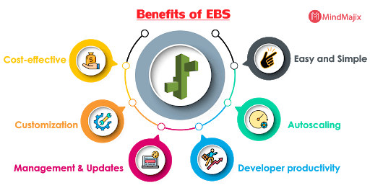

Following are the few benefits of the Elastic Beanstalk:

1. **Easy and simple:** Elastic Beanstalk enables you to manage and deploy the application easily and quickly.
2. **Autoscaling:** Beanstalk scales up or down automatically when your application traffic increases or decreases.
3. **Developer productivity:** Developers can easily deploy the application without any knowledge, but they need to maintain the application securely and user-friendly.
4. **Cost-effective:** No charge for Beanstalk. Charges are applied for the AWS service resources which you are using for your application.
5. **Customization:** Elastic Beanstalk allows users to select the configurations of AWS services that users want to use for application development.
6. **Management and updates:** It updates the application automatically when it changes the platform. Platform updates and infrastructure management are taken care of by AWS professionals.

**30. Define regions and availability zones in Amazon EC2.**

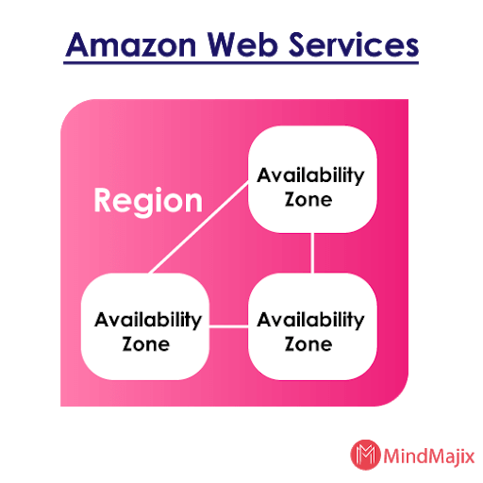

Amazon web service has a global infrastructure that is divided into availability zones and regions. Each region is divided into a geographic area and it has multiple isolated locations called availability zones.

**31. What is Amazon EC2 Root Device Volume?**

When the developer launches the instance, the root device volume is used to boot the instance that contains the image. When the developer introduces the Amazon EC2, all AMIs are propped up by an Amazon EC2 instance store.

**32. What is Server Load Balancing?**

A Server load balancer (SLB) provides content delivery and networking services using load balancing algorithms. SLB distributes the network traffic equally across a group of servers to ensure high-performance application delivery.

**33. How does a server load balancer work?**

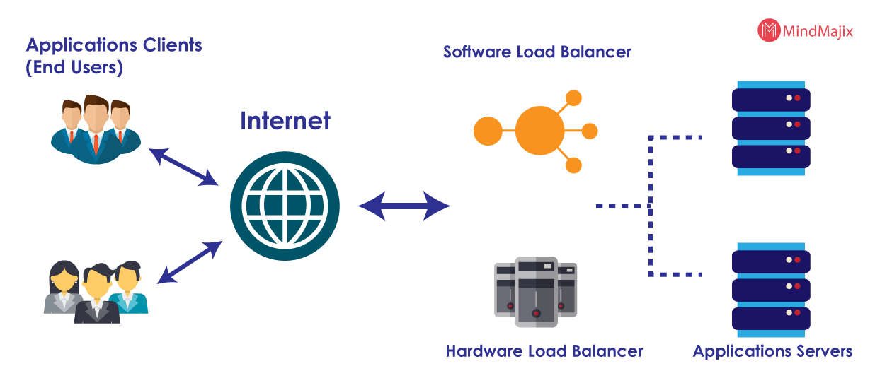

The server load balancer works based on two approaches. They are:

* Transport level load balancing
* Application-level load balancing

**34. What are the advantages of the Server load balancer?**

The advantages of server load balancer are as follows:

* Increases scalability
* Redundancy
* Maintenance and performance

**35. Explain the process to secure the data for carrying in the cloud.**

One thing that must be taken into consideration is that no one should resize the data while it is moving from one point to another. The other thing to consider is there should not be any kind of leakage with the security key from the multiple storerooms in the cloud. Dividing the information into different types and encrypting it into valid methods could help you in securing the data in the cloud.

**36. What are the layers available in cloud computing?**

Below listed are the various layers of cloud computing

**SaaS:** Software as a Service

**PaaS:** Platform as a Service

**IaaS:** Infrastructure as a Service

|  |
| --- |
|  |

**37. Explain the layers of Cloud architecture?**

We have five different types of layers available, which are:

* SC- Storage controller
* CC- cluster controller
* NC- Node controller
* Walrus
* CLC- cloud controller

**38. What are the reserved instances?**

It is nothing but a reservation of resources for one or three years and utilized whenever you need it. The reservation comes on a subscription basis available for a term of 1 year and three years. The hourly rate goes down as the usage increases. Purchasing reservations isn’t just associated with the reservation of resources, but also, comes with the capacity that is required for a particular zone.

**39. What is meant by a cloud watch?**

Cloud watching is a monitoring tool in Amazon Web Services with which you can monitor different resources of your organization. You can have a look at various things like health, applications, network, etc.

**40. How many types of cloud watches do we have?**

We have two types of cloud watches: essential monitoring and detailed monitoring. The necessary tracking will come to you free of cost, but when it comes to detailed control, you need to pay for it.

**41. Explain the cloud watch metrics that are meant for EC2 instances?**

The available metrics for EC2 instances are Disk reads, CPU utilization, network packets out, CPUCreditUsage, Disk writes, network packets, networkOut, and CPUCreditBalance.

**42. What would be the minimum and maximum size of the individual objects that you can store in S3?**

The minimum size of the object that you can store in S3 is 0 bytes, and the maximum size of an individual object that you can save is 5TB.

**43. Explain the various storage classes available in S3?**

Below mentioned are the storage classes available in S3.

* Standard frequency accessed
* One-zone infrequency accessed
* RRS - reduced redundancy storage
* Standard infrequency accessed
* Glacier

**44. What are the methods to encrypt the data in S3?**

We have three different methods available for encrypting the data in S3. They are as follows.

* Server-Side Encryption - C
* Server-Side Encryption - S3
* Server-Side Encryption - KMS

**45. On what basis the pricing of the S3 is decided?**

The pricing for S3 is decided by taking into consideration the below topics.

1. Data transfer
2. Storage used
3. Number of requests
4. Transfer acceleration
5. Storage management

**AWS Interview Questions - Advanced Level**

*Below are the Advanced AWS Interview Questions for Experienced Professionals*

**46. Is the property of broadcast or multicast supported by Amazon VPC?**

No, at present, [Amazon VPC](https://docs.aws.amazon.com/vpc/latest/userguide/what-is-amazon-vpc.html) is not supporting any multicast or broadcast.

**47. How many IP addresses are allowed for each account in AWS?**

For each AWS account, 5 VPC elastic addresses are allowed.

**48. What is meant by Edge location?**

The actual content is cached at the places called edge locations. So whenever a user searches for the content, he will find the same at the edge locations.

**49. What is Snowball?**

Snowball is an option available in AWS to transport. Using snowball, one can transfer the data into AWS and out of it. It helps us in transporting massive amounts of data from one destination to another. It helps in lowering the networking expenditure.

**50. Explain the advantages of auto-scaling?**

Below listed are the advantages of autoscaling.

* Better availability
* Better cost management
* High fault-tolerant

**51. What is a Subnet?**

When a large amount of IP addresses are divided into small chunks, then these tiny chunks are called Subnets.

**52. What is the number of subnets that we can have per VPC?**

Under one VPC, we can have 200 subnets.

**53. What is AWS CloudTrail?**

AWS Cloudtrail is an AWS service that helps you to enable governance, risk auditing, and compliance of your AWS account. Cloud trail records events when actions are taken by the role, user, or an AWS service. Events include when actions are taken by AWS command-line interface, AWS management console, APIs, and AWS SDKs.

**54. What is meant by Elasticache?**

Elasticache is a web service that makes the path easier to deploy and store the data in the cloud easily.

**55. Explain AWS Lambda.**

AWS Lambda is a computational service that enables you to run code without maintaining any servers. It automatically executes the code whenever needed. You are required to pay for the time that you have used it for. Lambda enables you to run the code virtually for any kind of application without managing any servers.

**56. What is Geo Restriction in CloudFront?**

It is an important feature available in AWS which helps you in preventing the users from accessing the content from specific regions. CloudFront is useful for distributing the content only to desired locations.

**57. What is Amazon EMR?**

Amazon EMR is a survived cluster stage and it helps you to create data structures before the intimation. Big data technologies such as Apache Hadoop and Spark are the tools that enable you to investigate a large amount of data. You can use the data for making analytical goals by using the apache hive and other relevant open source technologies.

**58. What is the actual boot time taken to instance stored-backend AMI?**

It takes less than 5 minutes to store the instance-backed AMI.

**59. Explain the essential features of the Amazon cloud search.**

Below listed are the essential features of Amazon cloud search.

* Prefixes Searches
* Enter text search
* Boolean searches
* Range searches
* Autocomplete Advice

**60. Give a few examples of DB engines that are used in AWS RDS.**

Following are few examples of DB engines that are used in AWS RDS:

* MariaDB
* OracleDB
* MS-SQL DB
* MYSQL DB
* Postgre DB

**61. What is the security group?**

In AWS the in and out traffic to instances is controlled with virtual firewalls which are known as Security groups. Security groups allow you to control traffic based on various aspects such as protocol, port, and source destination.

**62. What is the difference between block storage and file storage?**

**Block Storage:** it functions at a lower level and manages the data asset of blocks.

**File Storage:** The file storage operates at a higher level or operational level and manages data in the form of files and folders.

**63. Explain the types of Routing policies available in Amazon route S3.**

* Latency-based
* Weighted
* Failover
* Simple
* Geolocation

**64. List the default tables that we get when we create AWS VPC.**

* Network ACL
* Security group
* Route table

**65. List the different ways to access AWS.**

We have three different ways to access AWS, such as:

* Console
* SDK
* CLI

**66. What are the EBS volumes?**

The EBS is the abbreviation for Elastic Block Stores. These blocks act as a persistent volume that can be attached to the instances. The EBS volumes will store the data even if you stop the instances.

**67. How can you control the security of your VPC?**

You can use security groups, network access controls (ACLs), and flow logs to control your VPC security.

**Most Frequently Asked AWS Interview Questions - FAQs**

**68. Does Amazon support region base services on all services?**

No, it is not providing region-specific usage on all its services. But most of the services are region-based.

**69. What is EBS in AWS?**

Elastic block storage (EBS) is a storage system that is used to store persistent data. EBS is designed to provide block-level storage volumes and to use EC2 instances for both transactions and throughput-intensive workloads at any scale.

**70. How many AWS services are there in 2020?**

As of September 2019, the AWS Serverless Application repository is available in the AWS GovCloud (US-East) region. With this service, the availability of services is increased to a total of 18 AWS regions across North America, South America, the EU, and the Asia Pacific.

**71. Which AWS region is the cheapest?**

The US standard is the cheapest region; it is also the most established AWS region.

**72. What is the maximum size of an S3 bucket?**

The maximum size of an S3 bucket is 5 terabytes.

**73. What are the most popular AWS Services?**

1. Amazon S3
2. AWS Lambda
3. Amazon Glacier
4. Amazon EC2
5. Amazon SNS
6. Amazon CloudFront
7. Amazon EBS
8. Amazon Kinesis
9. Amazon VPC
10. Amazon SQ

|  |
| --- |
|  |

**74. Is AWS RDS free?**

Yes, AWS RDS is a free tier. RDS helps the AWS customers to get started with the management database service in the cloud for free.

**75. What is the difference between EBS and S3?**

Difference between EBS and S3

|  |  |
| --- | --- |
| **EBS** | **S3** |
| Highly scalable | Less scalable |
| It is a block storage | It is an object storage |
| EBS is faster than S3 | S3 is slower than EBS |
| User can access EBS only via the given EC2 instance | Anyone can access S3; it is a public instance. |
| It supports the File system interface | It supports Web interface |

**76. Is Amazon S3 a global service?**

Yes, Amazon S3 is a global service. It provides object storage through the web interface and it uses the Amazon scalable storage infrastructure to run its global e-commerce network.

**77. What are the benefits of AWS?**

AWS provides services to its users at a low cost. Amazon web services are easy to use and the user should not worry about security, servers, and databases. Amazon web services have several benefits which make user rely on them.